Computer workstation ergonomics checklist
Please use this checklist and the Griffith Workstation Set up Guide and Video to adjust your workstation to provide optimal comfort and performance. Suggested actions requiring further support or equipment must be reviewed and actioned by your manager.
More information on workstation set up can also be found via the Health, Safety & Wellbeing site.

Name: Click or tap here to enter text. | Element: Click or tap here to enter text. | Date: Click or tap to enter a date.

Chair, desk and seating position
Office Chair | Yes | No | N/A | Suggested Actions
Can the height, seat and backrest of the chair be adjusted to achieve the following: | ☐ | ☐ | ☐
Are your feet fully supported on the floor? | ☐ | ☐ | ☐
Can the backrest be adjusted to provide support for the lower back? | ☐ | ☐ | ☐
Is the seat pan able to provide suitable support for the thighs? Ideally 2-3 finger width between the front of the chair and the back of your leg when seated comfortably. | ☐ | ☐ | ☐
If armrests are in place, do they allow the worker to get close to the workstation? | ☐ | ☐ | ☐
Is the base of the chair stable (at least 5 star base)? | ☐ | ☐ | ☐
Does the chair base have castors if on carpet, or glides if on a tiled or hard floor surface? | ☐ | ☐ | ☐
Desk | Yes | No | N/A | Suggested Actions
With the chair adjusted correctly, are the elbows bent to at least 90 degrees when hands are in the typing position on the keyboard?  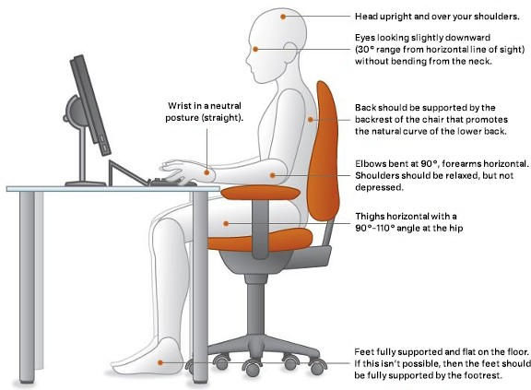 | ☐ | ☐ | ☐
If you answered no to the above, can the desk height be adjusted to achieve the correct seated posture? | ☐ | ☐ | ☐
If the desk height cannot be adjusted, is a footrest required? | ☐ | ☐ | ☐
If a corner desk is used, is a corner support or lozenge in place? | ☐ | ☐ | ☐
Is there sufficient space on the desk for all tasks and equipment? | ☐ | ☐ | ☐
Is the desk surface free from glare or reflection? | ☐ | ☐ | ☐
Sit / stand desk | Yes | No | N/A | Suggested Actions
When standing, is your posture at the desk the same as it is when in your correctly adjusted seating posture? | ☐ | ☐ | ☐
Do you alternate seated and standing posture and take regular breaks away from the workstation? (Refer to the Sit to Stand Workstation Guidelines) | ☐ | ☐ | ☐

Monitors and equipment

Keyboard and mouse | Yes | No | N/A | Suggested Actions
When using the keyboard and mouse, are the wrists straight and upper arms relaxed as in the images above? The keyboard should be thin style and not propped up on keyboard legs. | ☐ | ☐ | ☐
Is the keyboard close to the front edge of the desk allowing space for the wrist to rest on the desk surface? | ☐ | ☐ | ☐
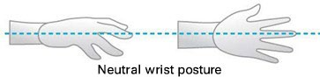  Is wrist support required to support the wrists in the required neutral posture? | ☐ | ☐ | ☐
Is the mouse at the same level and as close as possible to the keyboard? | ☐ | ☐ | ☐
Is the mouse comfortable to use? | ☐ | ☐ | ☐
Monitors and equipment | Yes | No | N/A | Suggested Actions
For multiple screens, is the most viewed screen positioned closer to the midline to avoid unnecessary twisting of the neck? | ☐ | ☐ | ☐
Is the monitor positioned at least arm’s length away?  Note: the monitor’s location is dependent on the size of the monitor, the font, screen resolution and the individual user eg. vision/use of bifocal spectacles etc. | ☐ | ☐ | ☐
Are you able to adjust the contrast and brightness and / or the font size to suit your vision requirements? | ☐ | ☐ | ☐
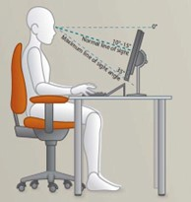  Is the top of the monitor screen at eye height?  (Eyes looking slightly downward at screen - refer to image). | ☐ | ☐ | ☐
Is the monitor screen free from glare? | ☐ | ☐ | ☐
Is a document holder or sloped reading surface in place for tasks involving reading or transcribing onto printed material? | ☐ | ☐ | ☐
Is there appropriate light for reading or writing documents? | ☐ | ☐ | ☐
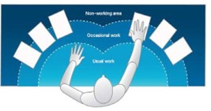  Are frequently used items located within the usual work area and items which are only used occasionally in the occasional work area? Refer to image below. | ☐ | ☐ | ☐
If a laptop is used for extended periods of time, is a riser used, along with a separate keyboard and mouse or is the laptop connected to a docking station and full-sized monitor? | ☐ | ☐ | ☐
Is a headset used if your role requires frequent telephone use? | ☐ | ☐ | ☐

Breaks and other considerations

Breaks | Yes | No | N/A | Suggested Actions
Are postural breaks taken every 30 minutes?  eg. standing, walking to printer / fax etc.? | ☐ | ☐ | ☐
Are regular eye breaks taken away from looking at the  monitor(s)? | ☐ | ☐ | ☐
‘Hot desking’ (when applicable) | Yes | No | N/A | Suggested Actions
Is there sufficient time, support and supervision to make the above adjustments. | ☐ | ☐ | ☐
Do you have suitable resources available to make the above adjustments? | ☐ | ☐ | ☐

Staff actions
Staff comments/actions summary:
Click or tap here to enter text.

Manager actions
Manager acknowledgement and actions: | Yes | N/A | Details
Action required | ☐ | ☐
Will be referred to Group / Element Health, Safety & Wellbeing Team for further assessment. | ☐ | ☐
Purchase of recommended equipment will be reviewed and appropriate equipment provide | ☐ | ☐

